
Cafeteria System


Team Members:-

Yousef Waleed Farid – 324243437@sha.edu.eg - 14B
Yousef Mohammed Ajeeb - 324243649@sha.edu.eg - 14B
Yousef Ebada El Said - 324243492@sha.edu.eg -14B
Yousef Refat Adly - 324243410@sha.edu.eg -14B
Yousef Ibrahim Abd El Ghani - 324243093@sha.edu.eg - 13B

- Cafeteria management system
- This system is responsible for managing users and prices in the cafeteria while giving authorization for the manager or employees with different account types.
- The manager can add items , edit them and adjust their prices or remove them completely , it also give them the ability to categorizes this items for better management, in addition to giving them the right to add a new user which can be a normal employee or another manager or partner, he can also see the history of the invoices for better analysis to the business.
- On the other hand, Employees can only make invoices with the items that the manager already added with the prices that the manager specified.

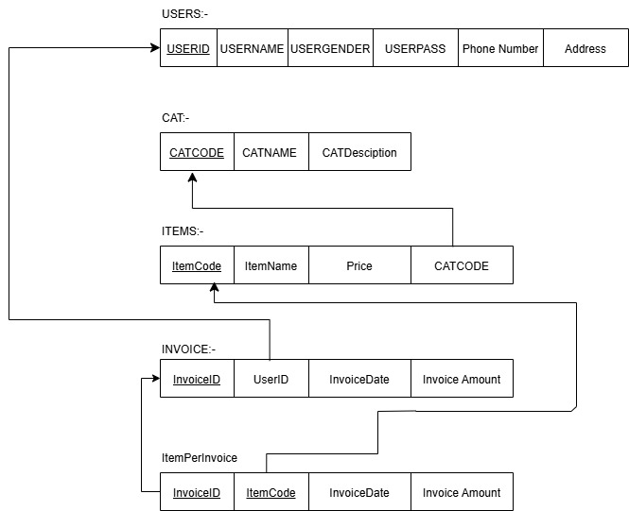
- Schema
- Current SQL Commands Used
- Create database CafeteriaDB
- GO
- USE CafeteriaDB
- GO
- CREATE TABLE Users(
- UserID int primary key IDENTITY(1,1) NOT NULL,
- UserName varchar(50) NOT NULL,
- UserGender varchar(6) NOT NULL,
- UserPass varchar(25) NOT NULL,
- UserPhone varchar(15) NULL unique,
- UserAddress varchar(150) NOT NULL,
- isAdmin bit Not Null
- )
- Go
- CREATE TABLE Cat(
- CatCode int primary key IDENTITY(1,1) NOT NULL,
- CatName varchar(50) unique NOT NULL,
- CatDesc varchar(100) NULL,
- )
- GO
- CREATE TABLE Item(
- ItemCode int primary key IDENTITY(1,1) NOT NULL,
- ItemName varchar(50) NOT NULL,
- ItemPrice money NOT NULL,
- ItemCat int NOT NULL foreign key references Cat(CatCode)
- on delete cascade on update cascade
- )
- GO
- CREATE TABLE Invoice(
- InvoiceID int primary key IDENTITY(1,1) NOT NULL,
- UserID int foreign key references Users(UserID)
- on delete cascade on update cascade,
- InvoiceDate date NOT NULL default getdate(),
- InvoiceAmount int NOT NULL,
- )
- GO
- Create Table ItemPerInvoice(
- itemCode int foreign key refrences item(ItemCode),
- invoiceCode int foreign key refrences Invoice(InvoiceID)
- )
- GO

/*Commands for Categories(Cat) Table*/
- select * from Cat

- Insert into Cat values ('{NameTB.Text}','{DescriptionTB.Text}')

- Update Cat set CatName = '{NameTB.Text}' , CatDesc = '{DescriptionTB.Text}' where CatCode = {key}

- Delete from Cat where CatCode = {key}

/*Commands for Item Table*/
- select itemCode, ItemName,cast(round(ItemPrice, 2) as decimal(10, 2)) as ItemPrice,ItemCat ,CatName from Item join cat on Item.ItemCat = Cat.CatCode

- Update Item set ItemName = '{NameTB.Text}',ItemPrice = {double.Parse(PriceTB.Text)},ItemCat = {int.Parse(CategoriesCB.SelectedValue.ToString())} where ItemCode = {key}

- Delete from Item where ItemCode = {key}

/*Commands for Users table*/
- Insert into Users values ('{NameTB.Text}','{GenderCB.SelectedText}','{PasswordTB.Text}','{PhoneTB.Text}','{AddressTB.Text}')

- Update Users set UserName = '{NameTB.Text}',UserGender = '{GenderCB.SelectedItem.ToString().ToLower()}', UserPass = '{PasswordTB.Text}',UserPhone = '{PhoneTB.Text}',UserAddress = '{AddressTB.Text}' where UserID = {key}

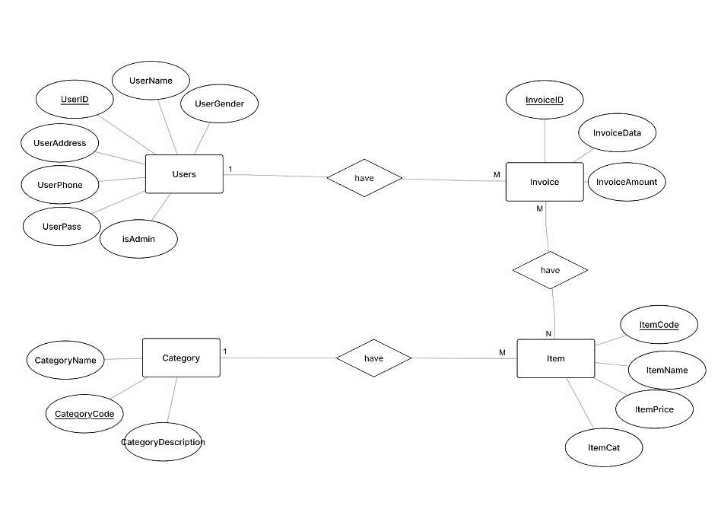
- ERD used

